Cloud Computing Assignment 4

Name: Naren Chandrashekhar

SRN: PES2UG20CS216

Section: D

Screenshot Outputs:

1a: Screenshot of Zookeeper Server having started.

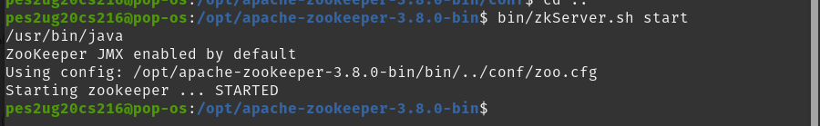

2a: Screenshot of Listing of the created Znodes

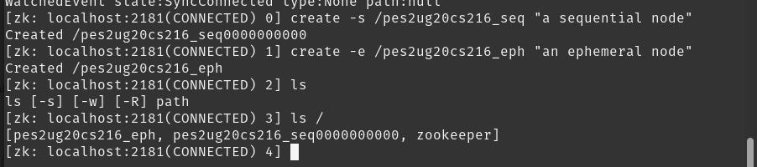

2b: Screenshot of Listing of the deleted ephemeral node

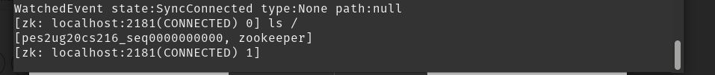

2c: Screenshot of Data and Metadata associated with the created sequential znode.

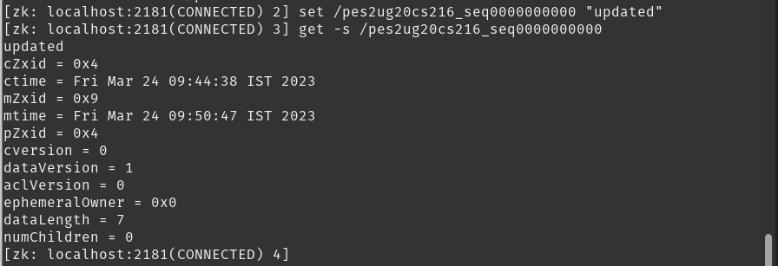

2d: Screenshot of Listing of all the children nodes

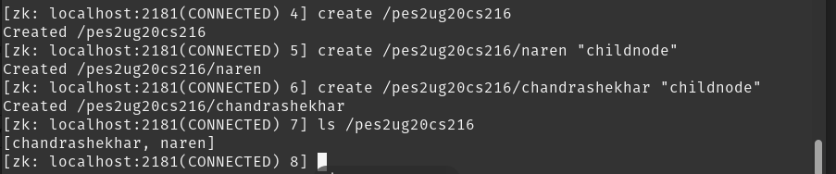

3a: Screenshot of each of the clients listing all the znodes

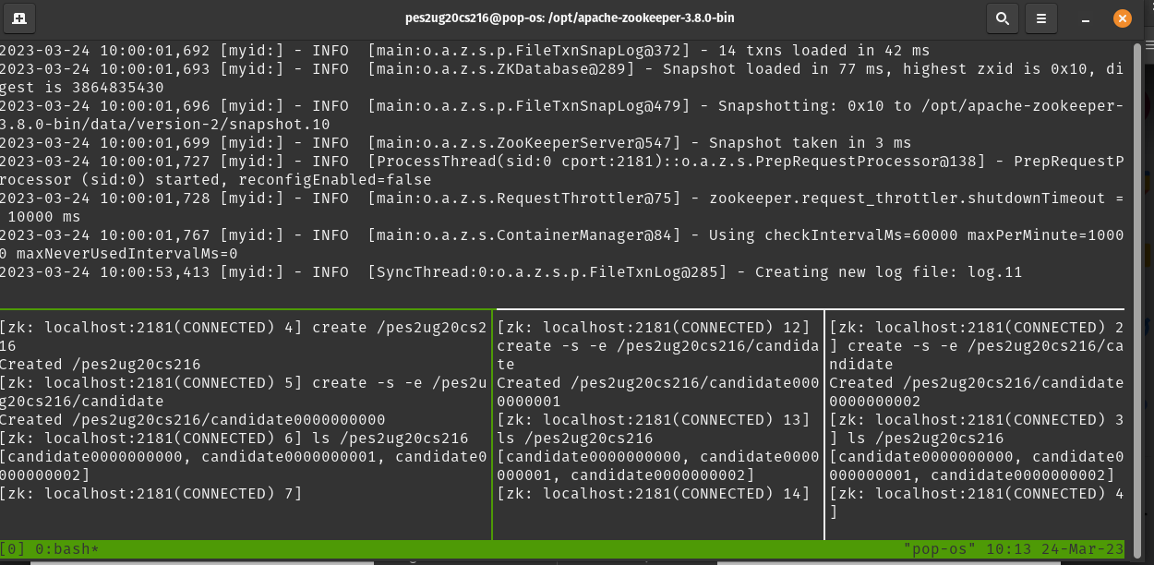

3b: Screenshot of the Watched Event and the Zookeeper Server logs.

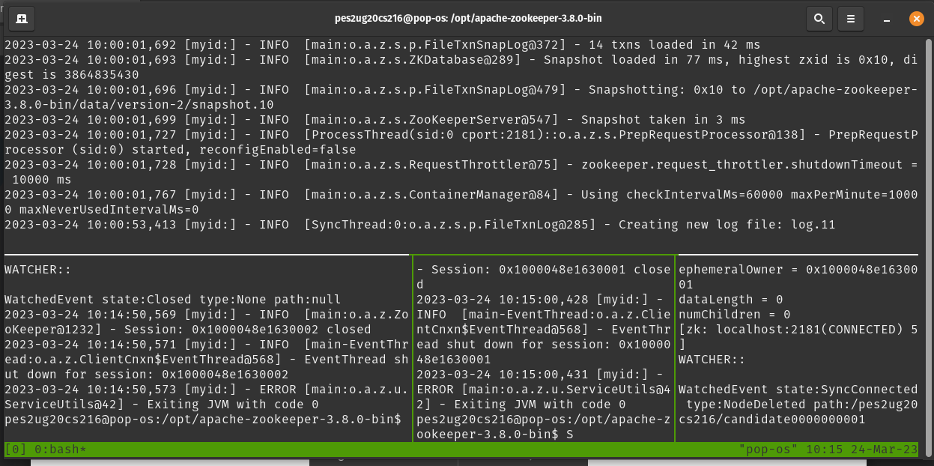

3c: Screenshot of the old leader coming back and having a new sequence number.

